Sphere-Based Composite Solids

Definition
# Source: AI Source: Provided by: [Data Path: Persons Table -> ID Column: 1, Name_En Column: Motasem Essam] -> From: [ChatGPT] on [7/25/2026]
Sphere-Based Composite Solids are three-dimensional geometric objects formed by joining a sphere with one or more other geometric solids that have flat surfaces, curved surfaces, or both.
The resulting solid contains at least one spherical component and may have a combination of flat faces, spherical surfaces, cylindrical surfaces, conical surfaces, and other curved surfaces.
Examples include:
- A sphere attached to a cylinder.
- A sphere joined to a cone.
- A hemisphere attached to a rectangular prism.
- A sphere combined with multiple cylinders and cones.
- Two or more spheres connected to other geometric solids.

Simple Definition
# Source: AI Source: Provided by: [Data Path: Persons Table -> ID Column: 1, Name_En Column: Motasem Essam] -> From: [ChatGPT] on [7/25/2026]
A sphere-based composite solid is a 3D shape made by combining a sphere with one or more other geometric solids.
For example, attaching a hemisphere to the end of a cylinder creates a composite solid with a cylindrical curved surface, a hemispherical curved surface, and an exposed flat circular base.

Geometric Representation
# Source: AI Source: Provided by: [Data Path: Persons Table -> ID Column: 1, Name_En Column: Motasem Essam] -> From: [ChatGPT] on [7/25/2026]
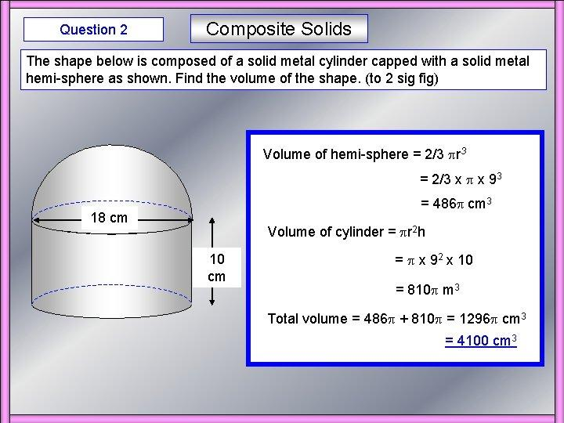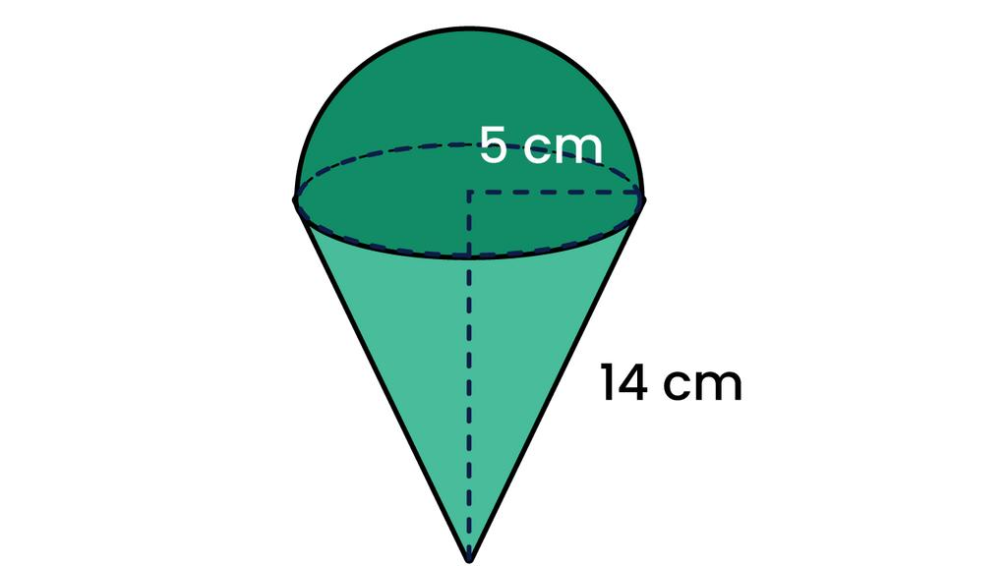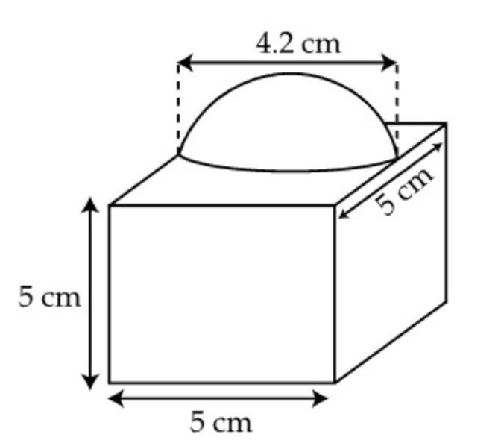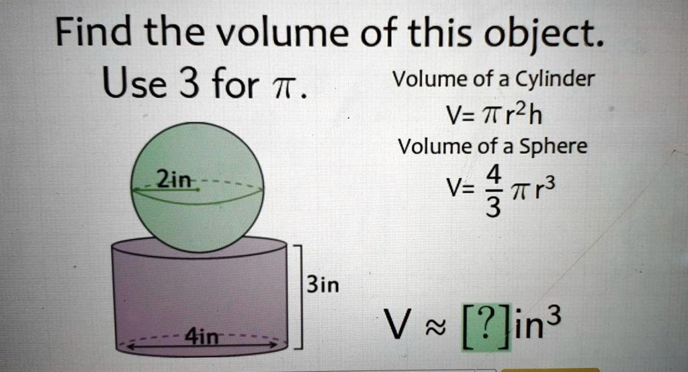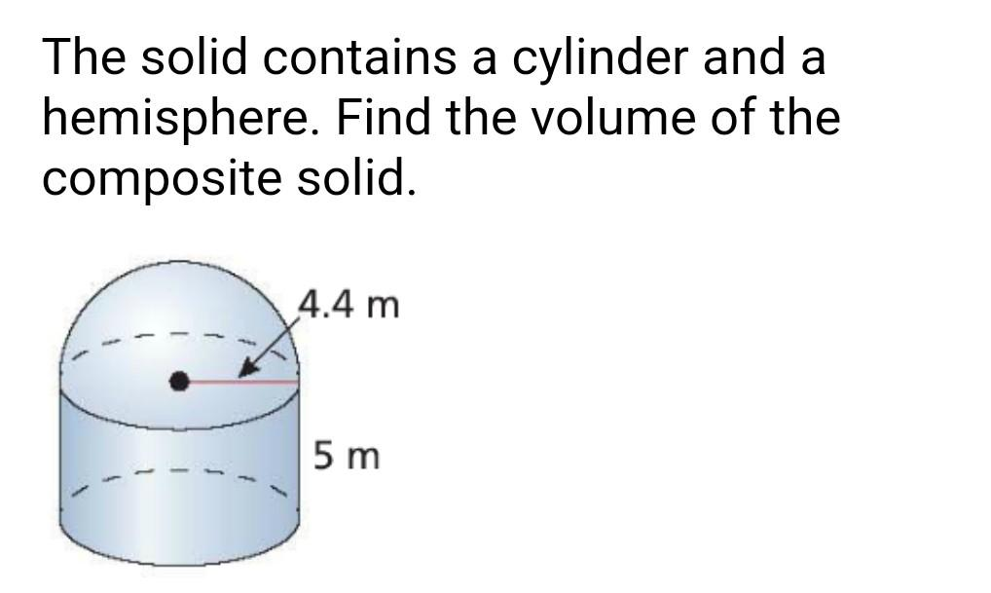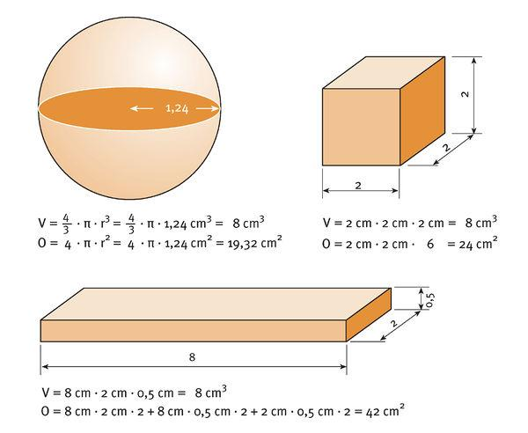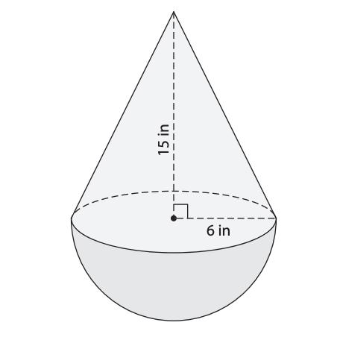
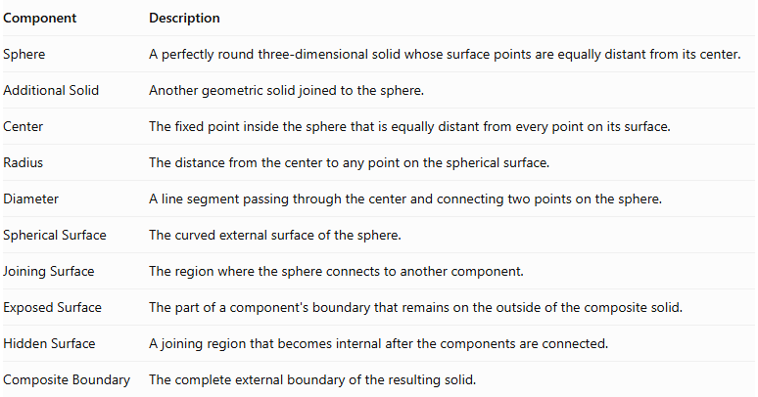
Component | Description
Sphere | A perfectly round three-dimensional solid whose surface points are equally distant from its center.
Additional Solid | Another geometric solid joined to the sphere.
Center | The fixed point inside the sphere that is equally distant from every point on its surface.
Radius | The distance from the center to any point on the spherical surface.
Diameter | A line segment passing through the center and connecting two points on the sphere.
Spherical Surface | The curved external surface of the sphere.
Joining Surface | The region where the sphere connects to another component.
Exposed Surface | The part of a component's boundary that remains on the outside of the composite solid.
Hidden Surface | A joining region that becomes internal after the components are connected.
Composite Boundary | The complete external boundary of the resulting solid.

Types of Sphere-Based Composite Solids

Sphere-Cylinder Composite Solids
# Source: AI Source: Provided by: [Data Path: Persons Table -> ID Column: 1, Name_En Column: Motasem Essam] -> From: [ChatGPT] on [7/25/2026]
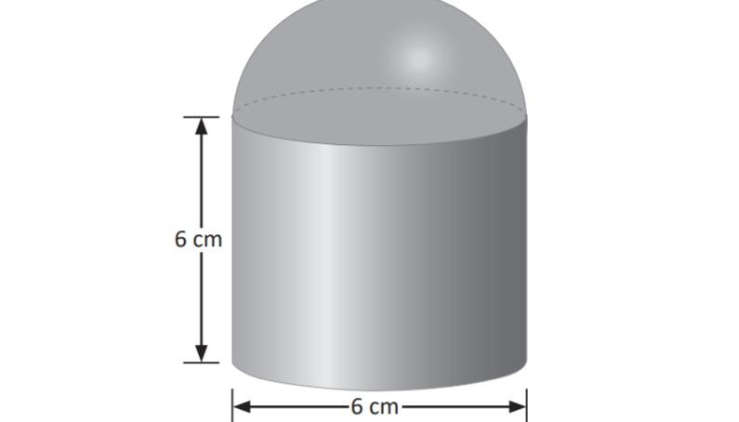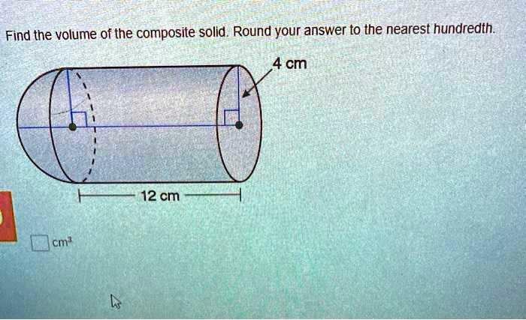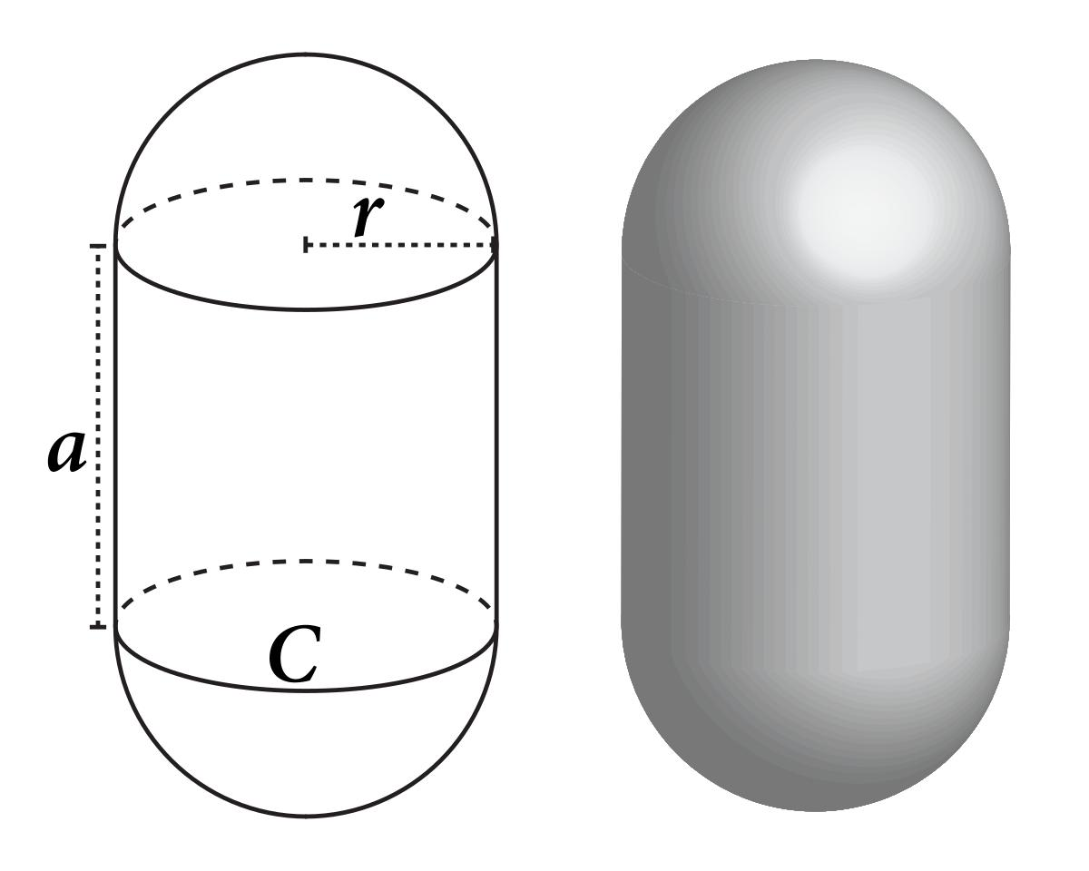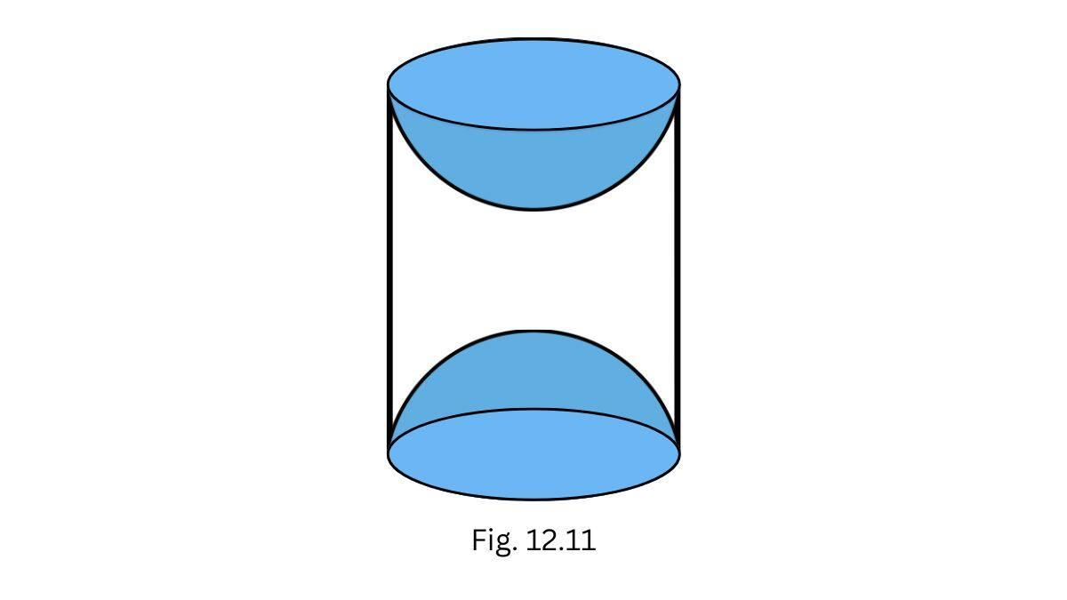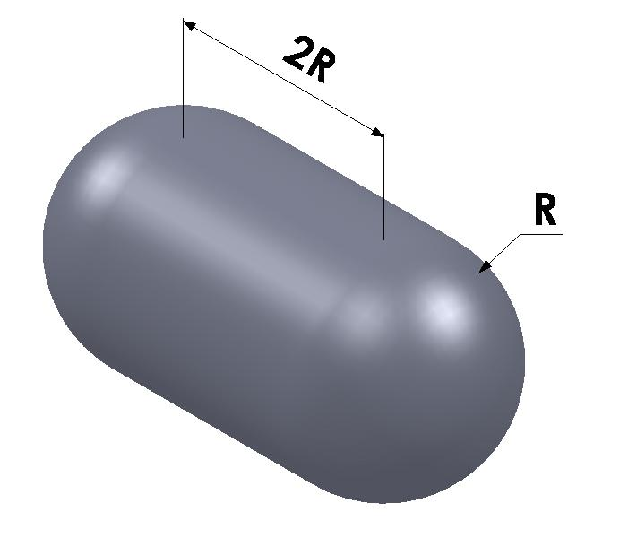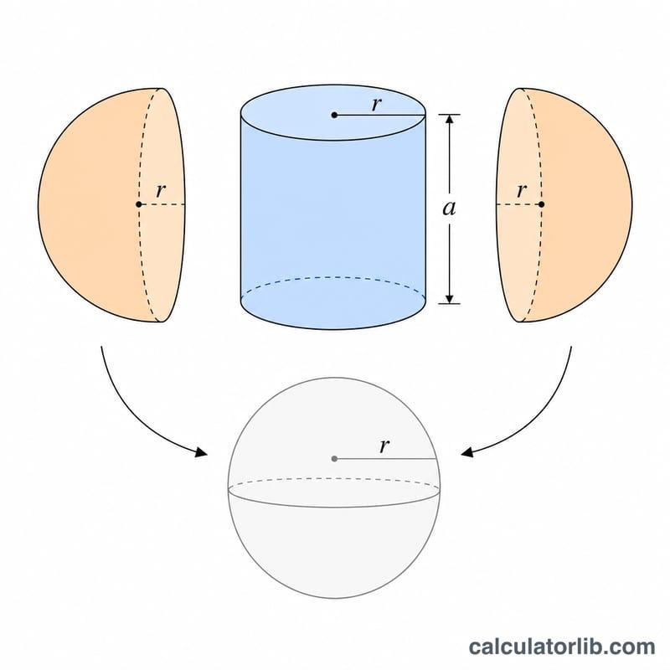
Formed by combining a sphere with one or more cylinders.
Examples:
- Sphere attached to one end of a cylinder.
- Sphere attached to both ends of a cylinder.
- Sphere attached to the lateral side of a cylinder.
- Multiple spheres attached to a cylinder.
- Sphere combined with multiple cylinders.

Sphere-Cone Composite Solids
# Source: AI Source: Provided by: [Data Path: Persons Table -> ID Column: 1, Name_En Column: Motasem Essam] -> From: [ChatGPT] on [7/25/2026]
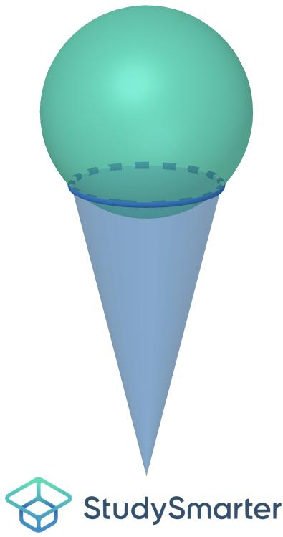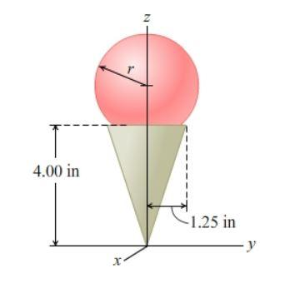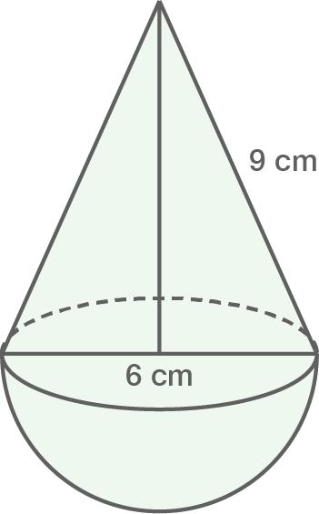
Formed by joining a sphere with one or more cones.
Examples:
- Sphere attached to the base of a cone.
- Sphere attached to the apex region of a cone.
- Sphere joined to a cone through a circular contact region.
- Multiple spheres attached to one or more cones.
- Sphere combined with cones arranged symmetrically.

Sphere-Hemisphere Composite Solids
# Source: AI Source: Provided by: [Data Path: Persons Table -> ID Column: 1, Name_En Column: Motasem Essam] -> From: [ChatGPT] on [7/25/2026]
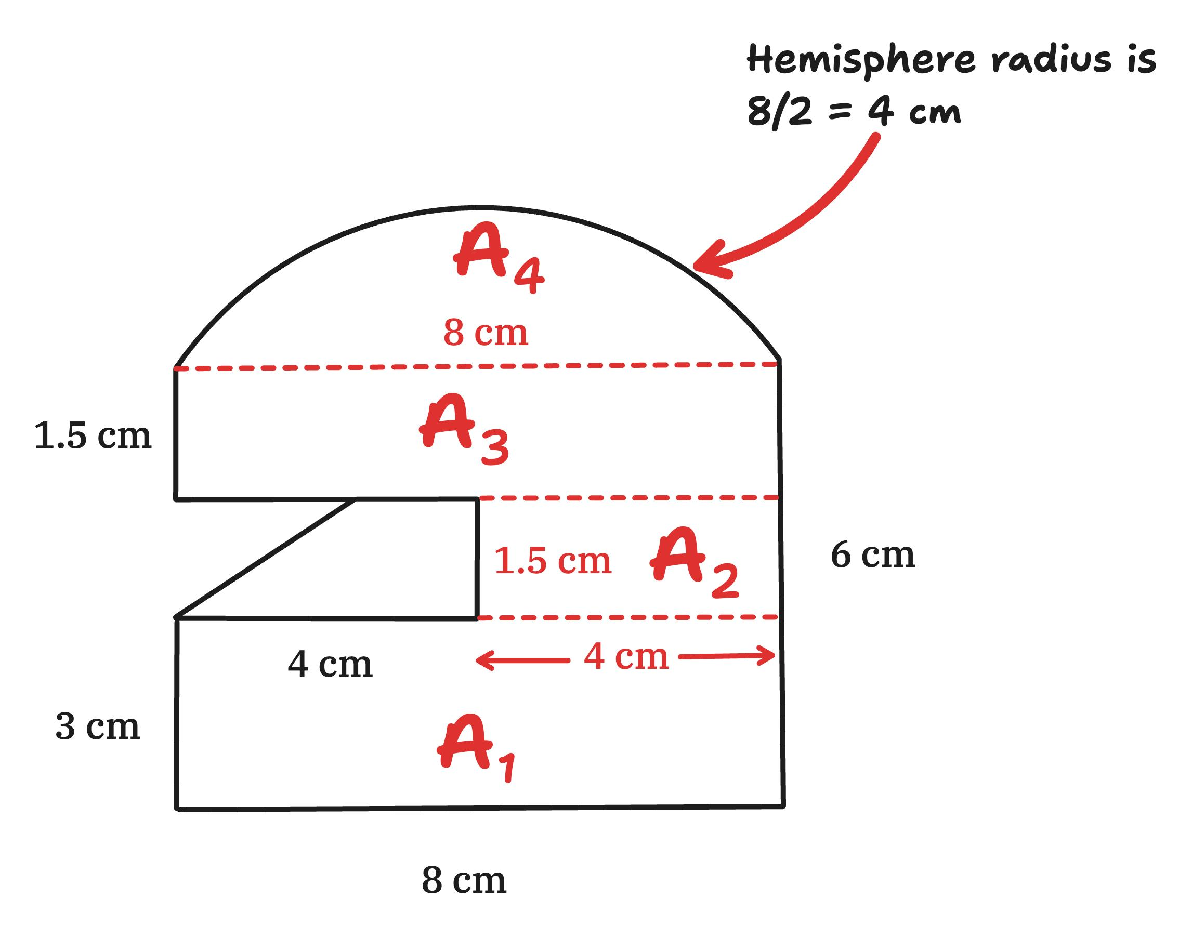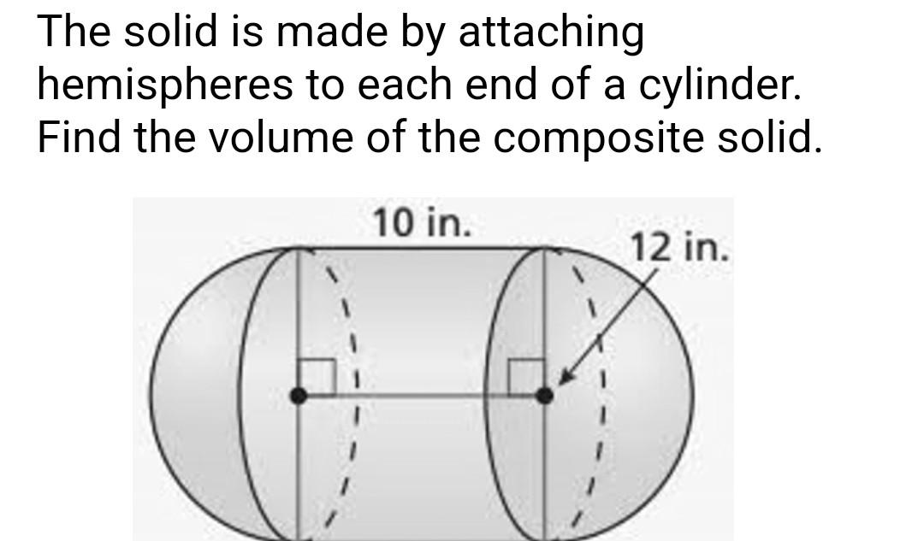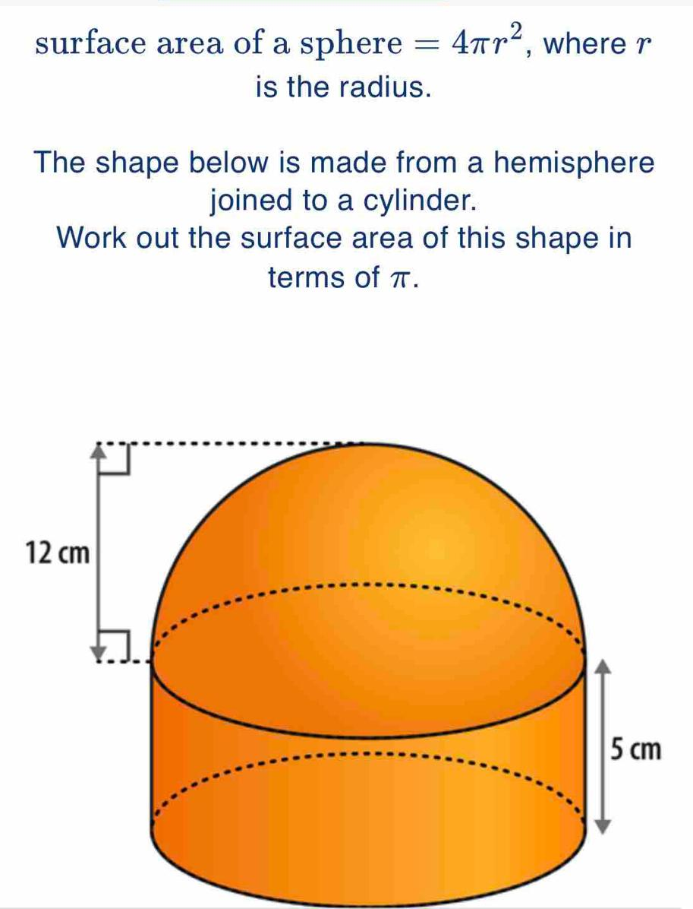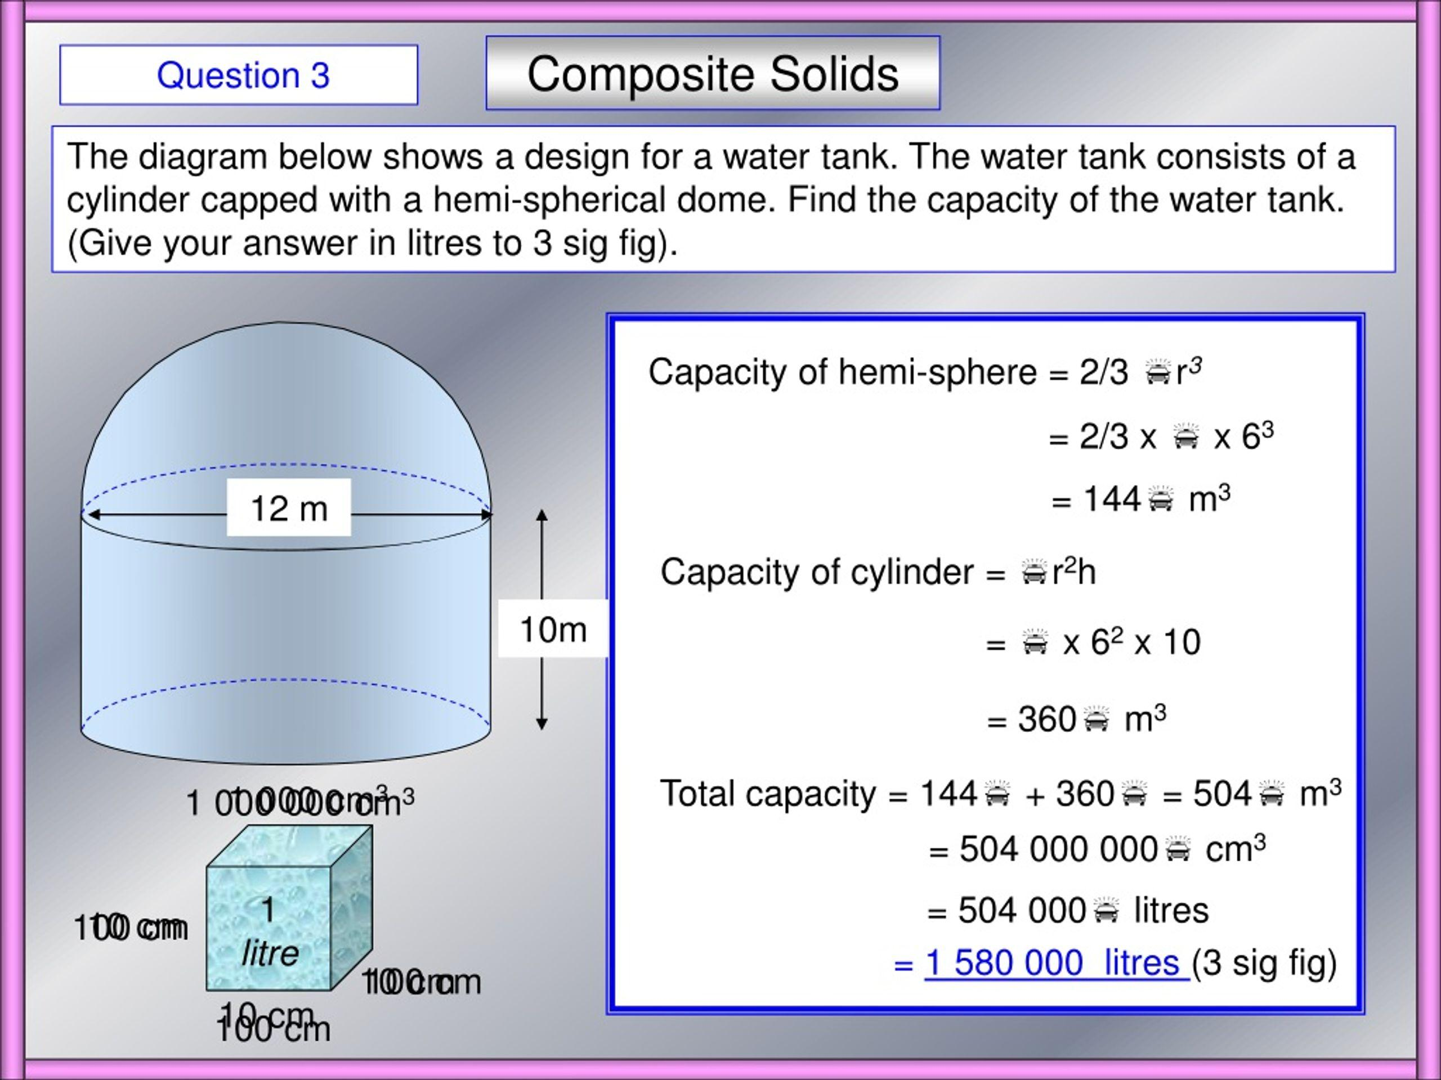
Formed by combining a sphere with one or more hemispheres.
Examples:
- Sphere attached to a hemisphere through a flat circular face.
- Sphere joined to multiple hemispheres.
- Two hemispheres attached to different regions of a sphere.
- Multiple spherical and hemispherical components combined.

Sphere-Frustum Composite Solids
# Source: AI Source: Provided by: [Data Path: Persons Table -> ID Column: 1, Name_En Column: Motasem Essam] -> From: [ChatGPT] on [7/25/2026]
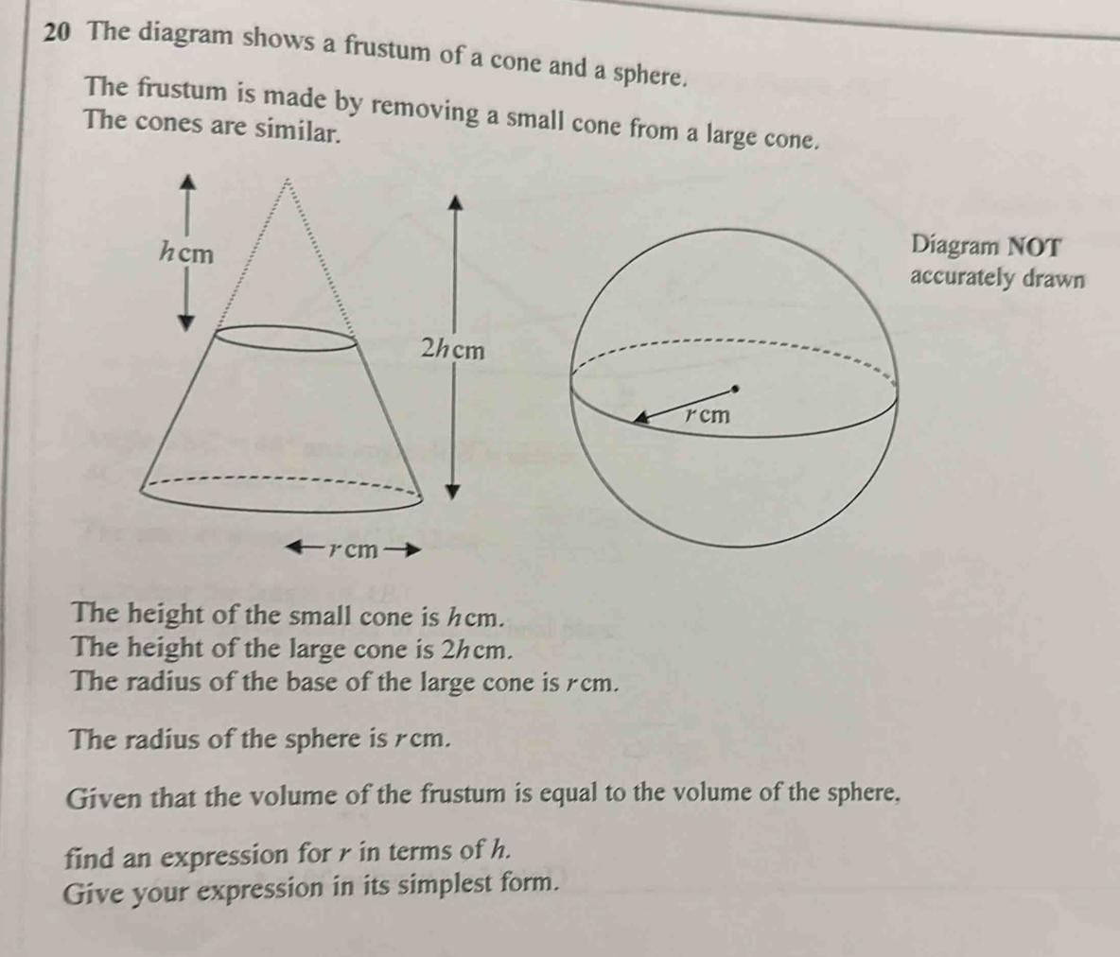
Formed by combining a sphere with one or more frustums.
Examples:
- Sphere attached to a conical frustum.
- Sphere attached to the smaller base of a frustum.
- Sphere attached to the larger base of a frustum.
- Multiple spheres and frustums combined.

Sphere-Prism Composite Solids
# Source: AI Source: Provided by: [Data Path: Persons Table -> ID Column: 1, Name_En Column: Motasem Essam] -> From: [ChatGPT] on [7/25/2026]
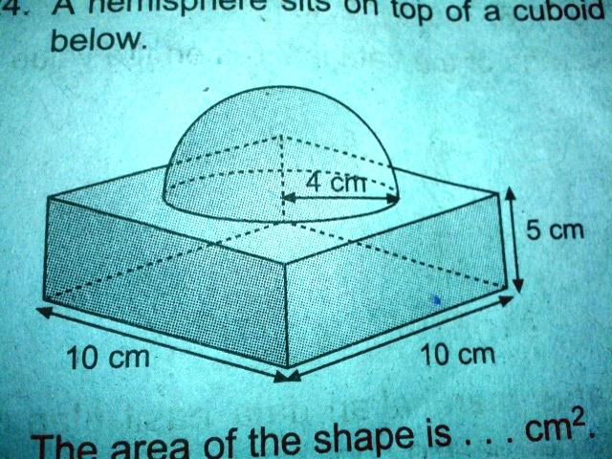
Formed by joining a sphere with one or more prisms.
Examples:
- Sphere with a rectangular prism.
- Sphere with a triangular prism.
- Sphere with a square prism.
- Sphere attached to multiple prisms.
- Multiple spheres combined with a prism.

Sphere-Pyramid Composite Solids
# Source: AI Source: Provided by: [Data Path: Persons Table -> ID Column: 1, Name_En Column: Motasem Essam] -> From: [ChatGPT] on [7/25/2026]
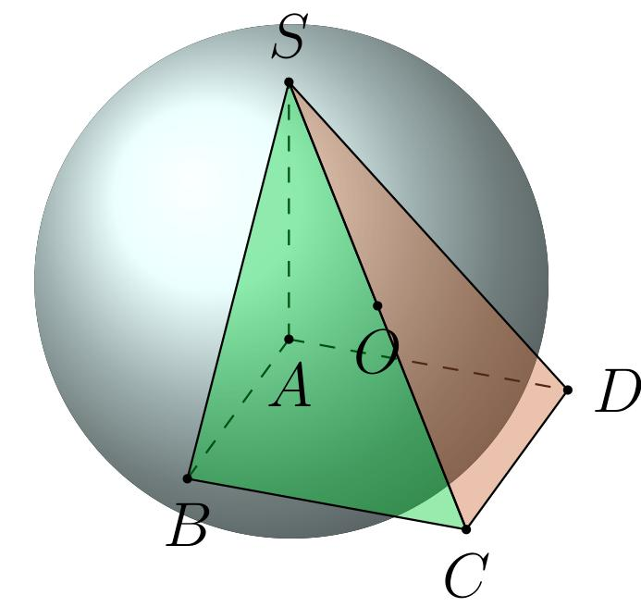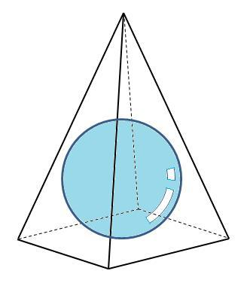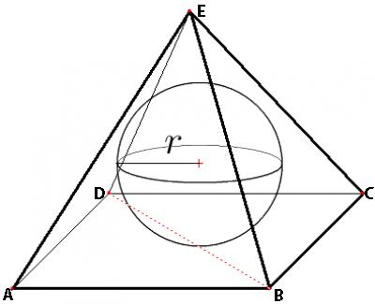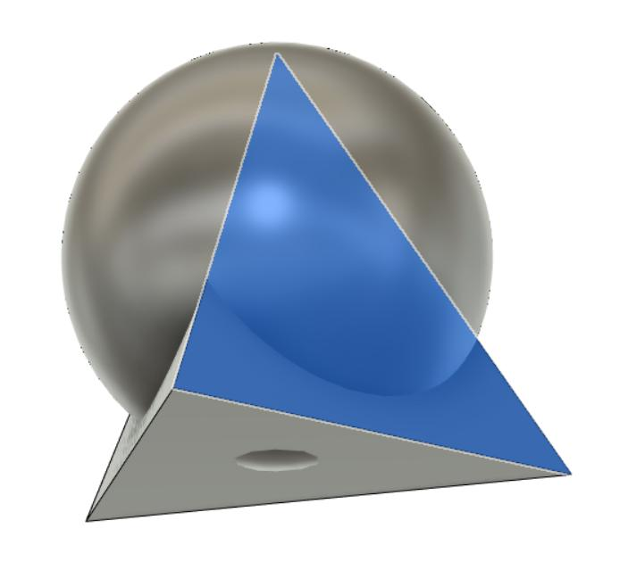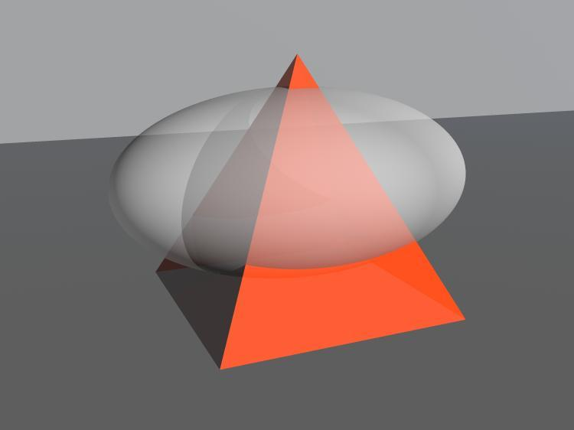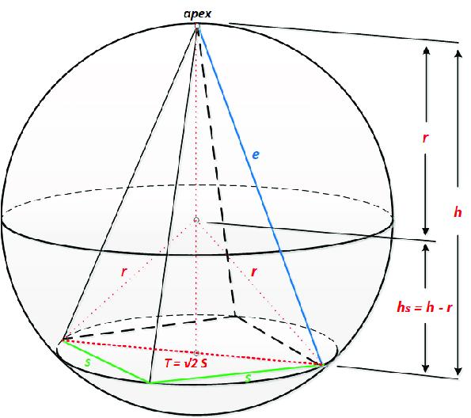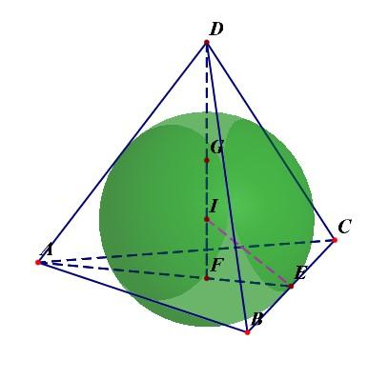
Formed by combining a sphere with one or more pyramids.
Examples:
- Sphere attached to a square pyramid.
- Sphere attached to a triangular pyramid.
- Sphere combined with multiple pyramids.
- Multiple spheres attached to pyramid-based structures.

Sphere with Multiple Curved-Solid Types
# Source: AI Source: Provided by: [Data Path: Persons Table -> ID Column: 1, Name_En Column: Motasem Essam] -> From: [ChatGPT] on [7/25/2026]
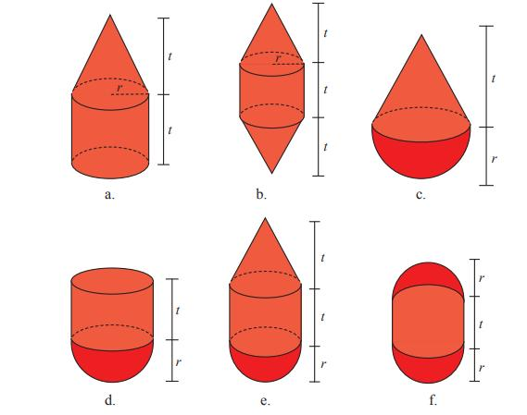
Formed by combining a sphere with two or more different types of curved solids.
Examples:
- Sphere with a cylinder and cone.
- Sphere with a hemisphere and frustum.
- Sphere with multiple cylinders and cones.
- Sphere combined with cylinders, cones, hemispheres, and frustums.

Sphere with Multiple Flat-and-Curved Solid Types
# Source: AI Source: Provided by: [Data Path: Persons Table -> ID Column: 1, Name_En Column: Motasem Essam] -> From: [ChatGPT] on [7/25/2026]
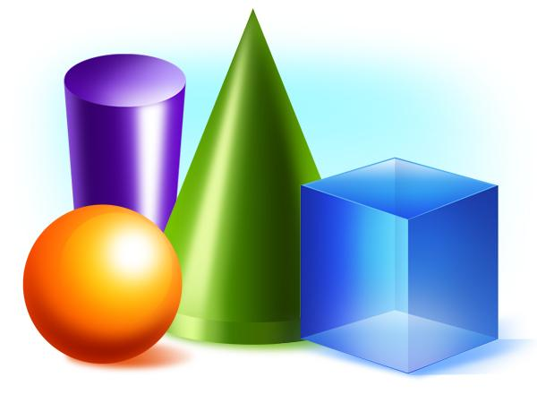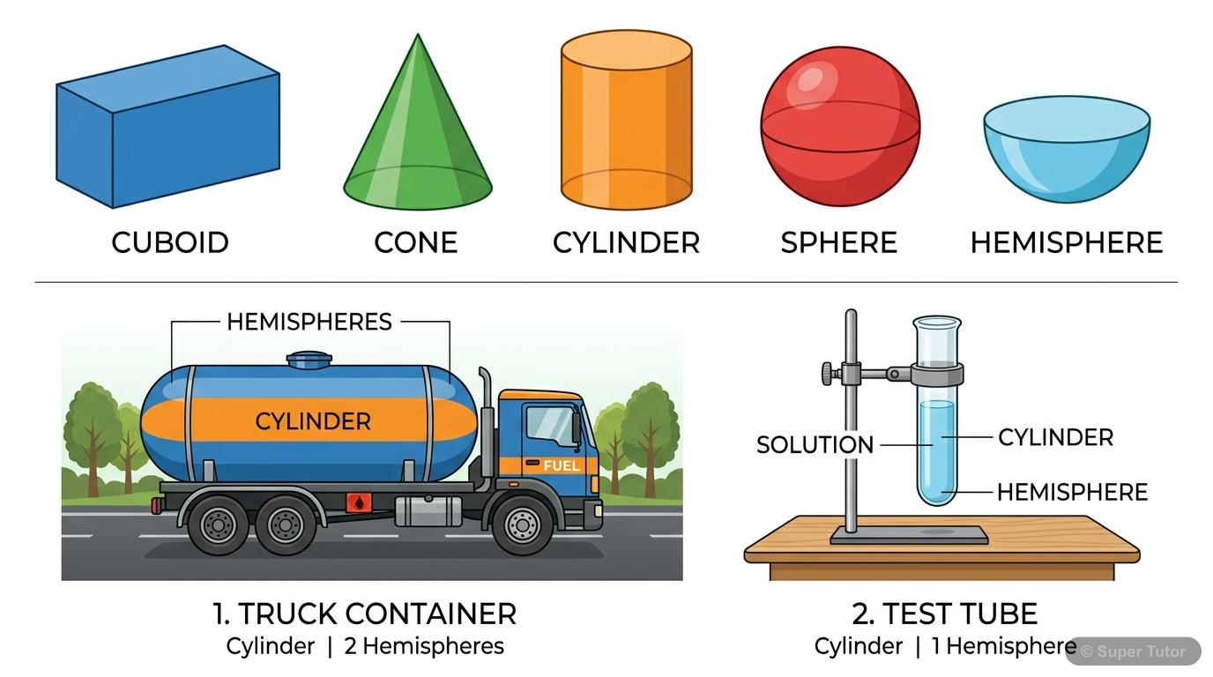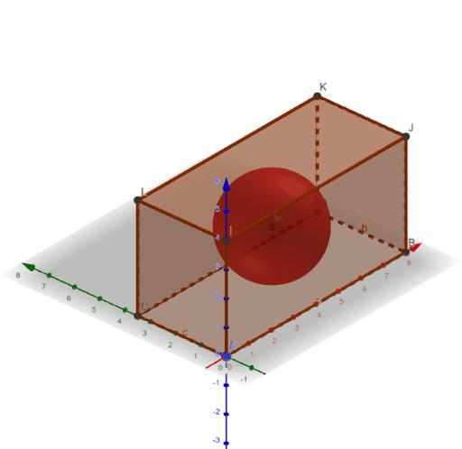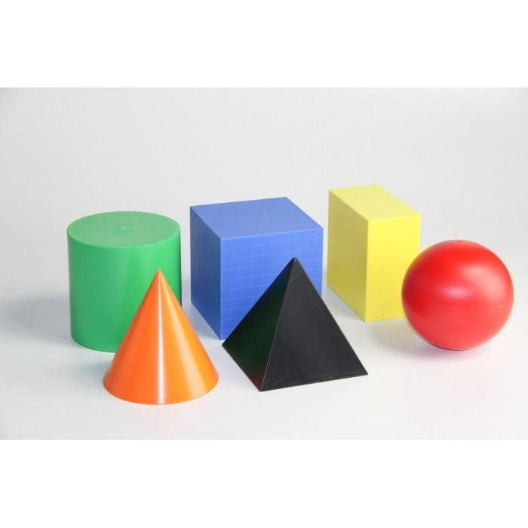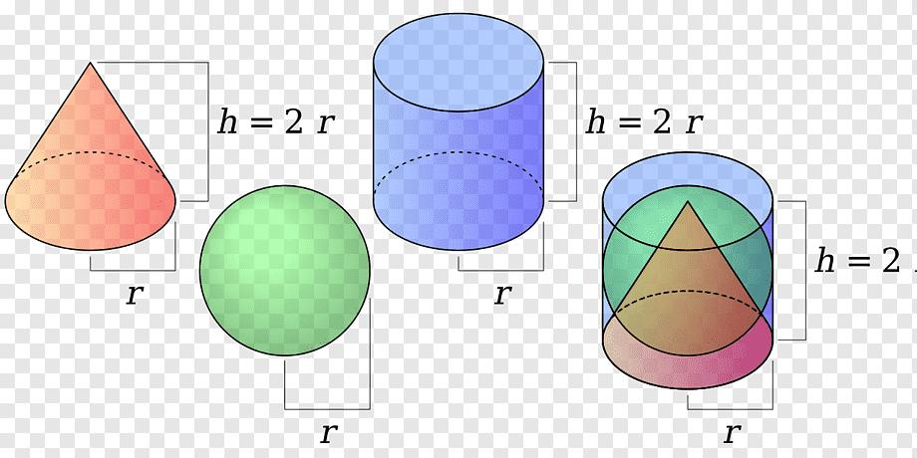
Formed by combining a sphere with multiple additional solids that include both flat-faced and curved-surface components.
Examples:
- Sphere with a rectangular prism and cylinder.
- Sphere with a pyramid and cone.
- Sphere with a prism, hemisphere, and cylinder.
- Sphere with multiple prisms, pyramids, cones, and cylinders.

Classification by Sphere Type
# Source: AI Source: Provided by: [Data Path: Persons Table -> ID Column: 1, Name_En Column: Motasem Essam] -> From: [ChatGPT] on [7/25/2026]
Sphere-based composite solids can be classified according to the spherical component used.
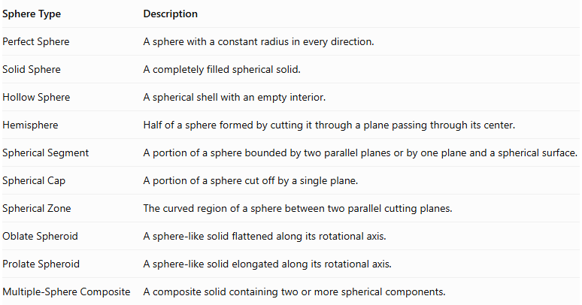
Sphere Type | Description
Perfect Sphere | A sphere with a constant radius in every direction.
Solid Sphere | A completely filled spherical solid.
Hollow Sphere | A spherical shell with an empty interior.
Hemisphere | Half of a sphere formed by cutting it through a plane passing through its center.
Spherical Segment | A portion of a sphere bounded by two parallel planes or by one plane and a spherical surface.
Spherical Cap | A portion of a sphere cut off by a single plane.
Spherical Zone | The curved region of a sphere between two parallel cutting planes.
Oblate Spheroid | A sphere-like solid flattened along its rotational axis.
Prolate Spheroid | A sphere-like solid elongated along its rotational axis.
Multiple-Sphere Composite | A composite solid containing two or more spherical components.
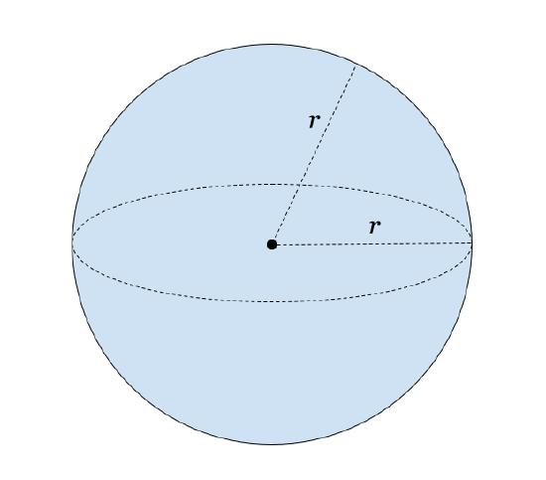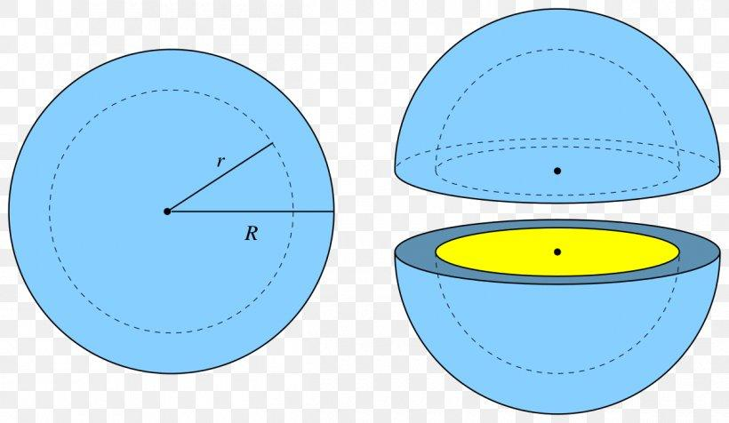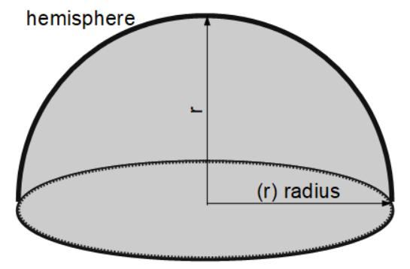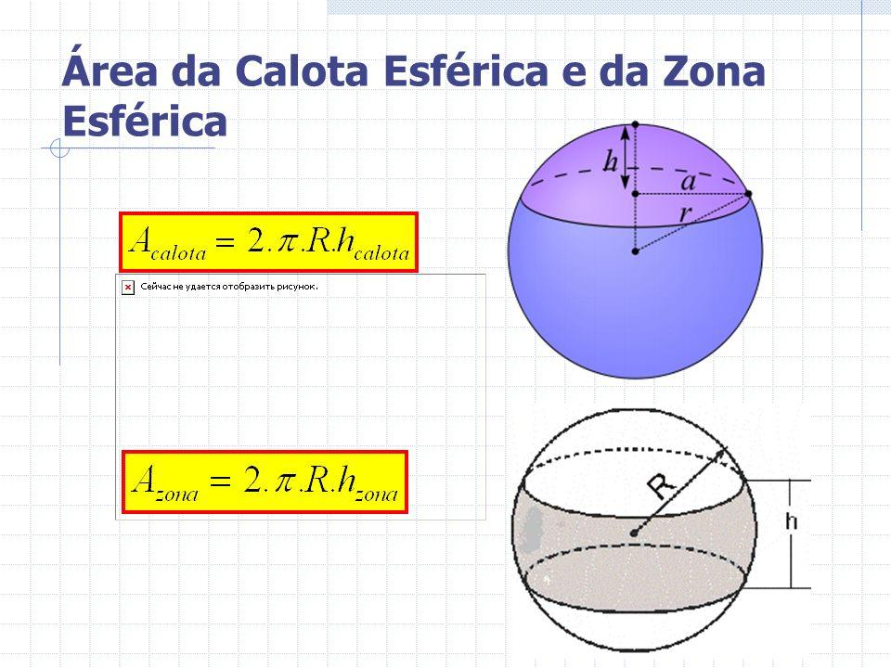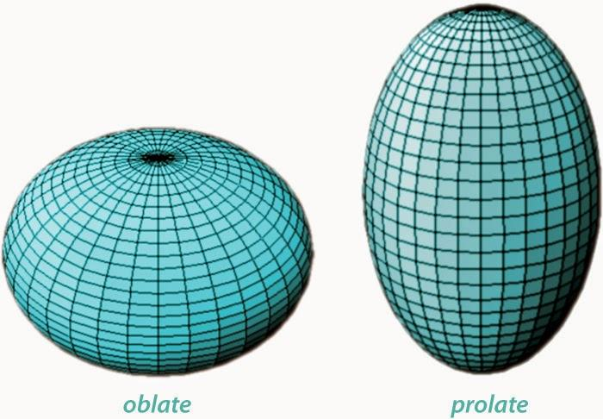

Classification by Arrangement
# Source: AI Source: Provided by: [Data Path: Persons Table -> ID Column: 1, Name_En Column: Motasem Essam] -> From: [ChatGPT] on [7/25/2026]
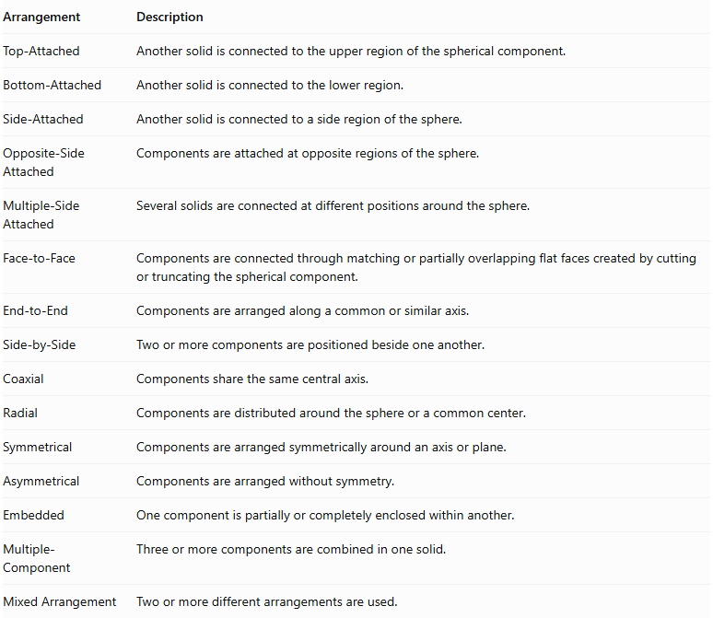
Arrangement | Description
Top-Attached | Another solid is connected to the upper region of the spherical component.
Bottom-Attached | Another solid is connected to the lower region.
Side-Attached | Another solid is connected to a side region of the sphere.
Opposite-Side Attached | Components are attached at opposite regions of the sphere.
Multiple-Side Attached | Several solids are connected at different positions around the sphere.
Face-to-Face | Components are connected through matching or partially overlapping flat faces created by cutting or truncating the spherical component.
End-to-End | Components are arranged along a common or similar axis.
Side-by-Side | Two or more components are positioned beside one another.
Coaxial | Components share the same central axis.
Radial | Components are distributed around the sphere or a common center.
Symmetrical | Components are arranged symmetrically around an axis or plane.
Asymmetrical | Components are arranged without symmetry.
Embedded | One component is partially or completely enclosed within another.
Multiple-Component | Three or more components are combined in one solid.
Mixed Arrangement | Two or more different arrangements are used.
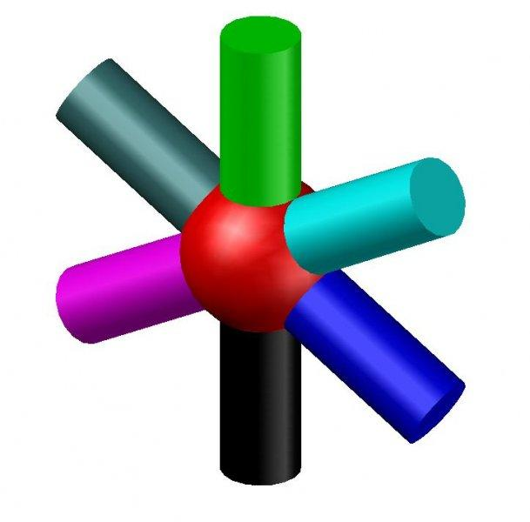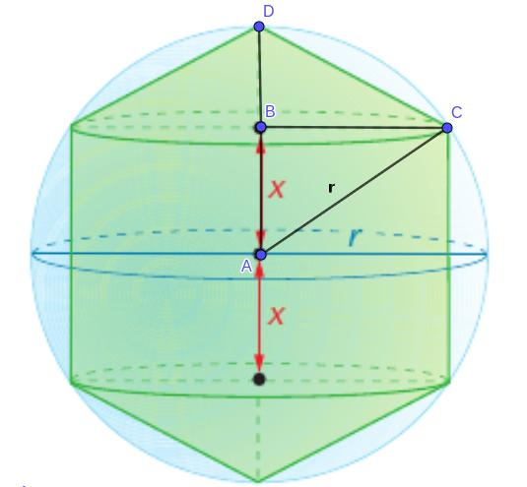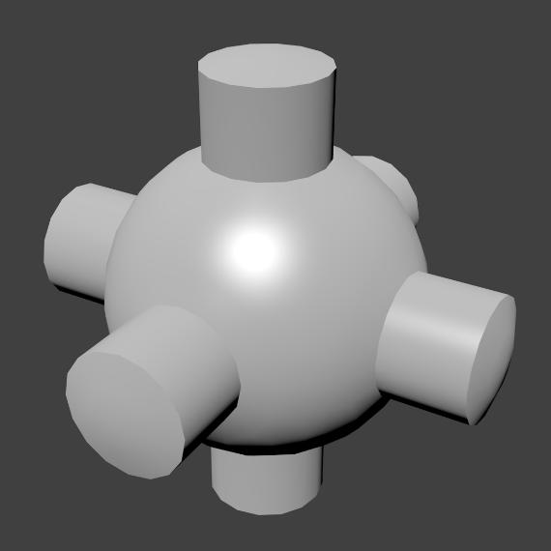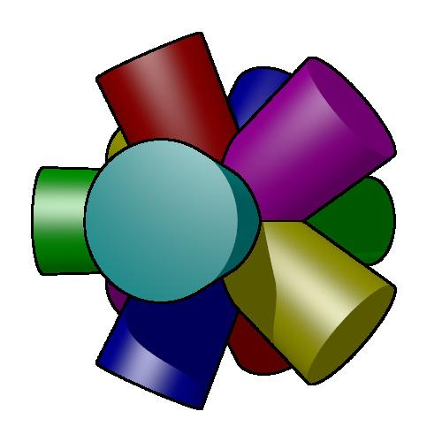
Geometric note: A complete sphere has no flat faces. Therefore, a solid cannot share a complete planar face with an unmodified sphere. Face-to-face connections generally require a spherical component to be cut or truncated, creating a flat circular joining face. If another solid merely touches an unmodified sphere at one point, the contact has zero area.

Classification by Surface Combination
# Source: AI Source: Provided by: [Data Path: Persons Table -> ID Column: 1, Name_En Column: Motasem Essam] -> From: [ChatGPT] on [7/25/2026]
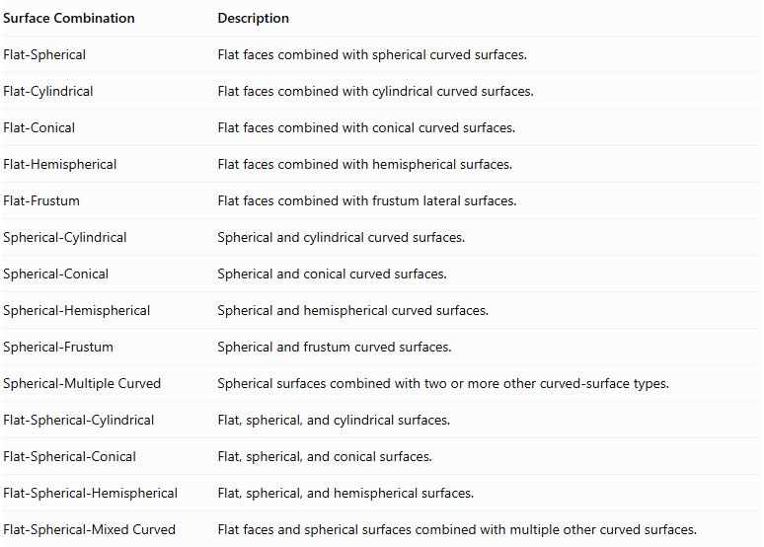
Surface Combination | Description
Flat-Spherical | Flat faces combined with spherical curved surfaces.
Flat-Cylindrical | Flat faces combined with cylindrical curved surfaces.
Flat-Conical | Flat faces combined with conical curved surfaces.
Flat-Hemispherical | Flat faces combined with hemispherical surfaces.
Flat-Frustum | Flat faces combined with frustum lateral surfaces.
Spherical-Cylindrical | Spherical and cylindrical curved surfaces.
Spherical-Conical | Spherical and conical curved surfaces.
Spherical-Hemispherical | Spherical and hemispherical curved surfaces.
Spherical-Frustum | Spherical and frustum curved surfaces.
Spherical-Multiple Curved | Spherical surfaces combined with two or more other curved-surface types.
Flat-Spherical-Cylindrical | Flat, spherical, and cylindrical surfaces.
Flat-Spherical-Conical | Flat, spherical, and conical surfaces.
Flat-Spherical-Hemispherical | Flat, spherical, and hemispherical surfaces.
Flat-Spherical-Mixed Curved | Flat faces and spherical surfaces combined with multiple other curved surfaces.

Mathematical Properties and Formulas

Volume
# Source: AI Source: Provided by: [Data Path: Persons Table -> ID Column: 1, Name_En Column: Motasem Essam] -> From: [ChatGPT] on [7/25/2026]
The total volume is calculated by combining the volumes of the components while accounting for any overlapping regions.
For components with no overlapping interiors:
$$V_{total}=V_{1}+V_{2}+⋯+V_{n}$$
For overlapping components:
$$V_{union}=V_{1}+V_{2}-V_{overlap}$$
For more than two overlapping components, all intersection regions must be accounted for.
Important volume formulas:
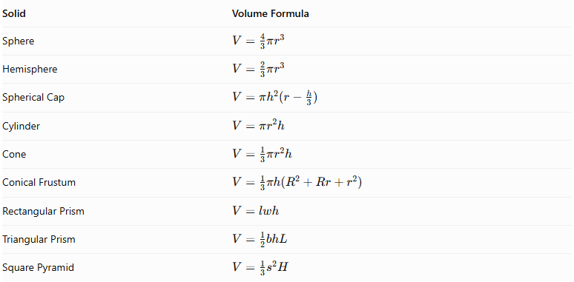
Solid | Volume Formula
Sphere | $$V=\frac{4}{3}πr^{3}$$
Hemisphere | $$V=\frac{2}{3}πr^{3}$$
Spherical Cap | $$V=πh^{2}(r-\frac{h}{3})$$
Cylinder | $$V=πr^{2}h$$
Cone | $$V=\frac{1}{3}πr^{2}h$$
Conical Frustum | $$V=\frac{1}{3}πh(R^{2}+Rr+r^{2})$$
Rectangular Prism | $$V=lwh$$
Triangular Prism | $$V=\frac{1}{2}bhL$$
Square Pyramid | $$V=\frac{1}{3}s^{2}H$$
Where:
- $r$ = sphere or circular-base radius.
- $R$ = larger radius of a frustum.
- $h$ = height of the relevant component or spherical cap.
- $l$ = length of a prism.
- $w$ = width.
- $b$ = triangular base width.
- $L$ = length of a triangular prism.
- $s$ = side length of a square base.
- $H$ = perpendicular height of a pyramid.

Surface Area
# Source: AI Source: Provided by: [Data Path: Persons Table -> ID Column: 1, Name_En Column: Motasem Essam] -> From: [ChatGPT] on [7/25/2026]
The external surface area includes only the surfaces that remain exposed after the components are combined.
For two solids joined through a complete matching planar face:
$${SA}_{external}={SA}_{1}+{SA}_{2}-2A_{joining}$$
For partial contact, subtract only the actual hidden contact regions. For curved intersections, calculate the exposed portions of the surfaces according to the resulting geometry.
Important surface-area formulas:
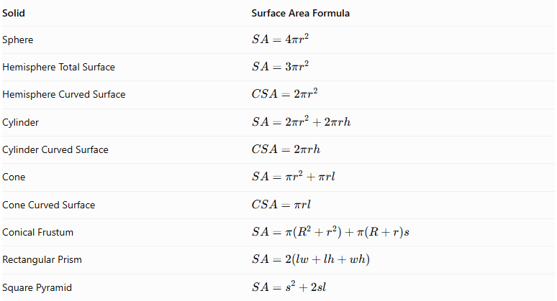
Solid | Surface Area Formula
Sphere | $$SA=4πr^{2}$$
Hemisphere Total Surface | $$SA=3πr^{2}$$
Hemisphere Curved Surface | $$CSA=2πr^{2}$$
Cylinder | $$SA=2πr^{2}+2πrh$$
Cylinder Curved Surface | $$CSA=2πrh$$
Cone | $$SA=πr^{2}+πrl$$
Cone Curved Surface | $$CSA=πrl$$
Conical Frustum | $$SA=π(R^{2}+r^{2})+π(R+r)s$$
Rectangular Prism | $$SA=2(lw+lh+wh)$$
Square Pyramid | $$SA=s^{2}+2sl$$
Where:
- $r$ = radius.
- $R$ = larger frustum radius.
- $h$ = perpendicular height.
- $l$ = cone or pyramid slant height, depending on the formula.
- $s$ = frustum slant height or square side length, depending on the formula.

Important Surface-Area Considerations
# Source: AI Source: Provided by: [Data Path: Persons Table -> ID Column: 1, Name_En Column: Motasem Essam] -> From: [ChatGPT] on [7/25/2026]
- A complete sphere has no flat base.
- A sphere touching another solid at a single point has zero-area contact.
- When a spherical component is cut by a plane, the resulting flat circular face may become a joining surface.
- A hemisphere's flat circular base becomes hidden when completely joined to another solid through that face.
- A sphere partially embedded in another solid has an exposed spherical region and a hidden intersection region.
- Spherical surfaces must be calculated according to the portion that remains exposed.
- The total external surface area is not necessarily the sum of the complete surface areas of the individual components.

Worked Examples

Example 1: Truncated Sphere with a Cylinder Attached
# Source: AI Source: Provided by: [Data Path: Persons Table -> ID Column: 1, Name_En Column: Motasem Essam] -> From: [ChatGPT] on [7/25/2026]
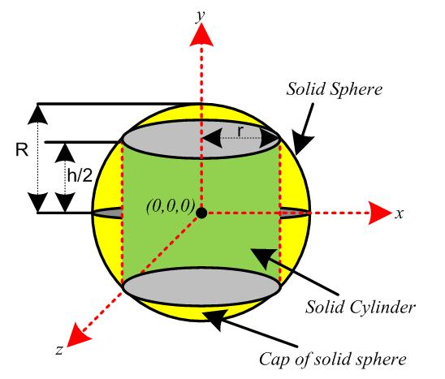
Given:
A sphere with radius 5 cm is cut by a plane located 3 cm from its center. The remaining larger spherical portion is joined to a cylinder through the resulting circular face.
Sphere:
- Original radius = 5 cm.
- Distance from center to cutting plane = 3 cm.
Cylinder:
- Radius = 4 cm.
- Height = 6 cm.
Find the total volume and external surface area.
Step 1: Calculate the radius of the circular joining face.
Using the Pythagorean theorem:
$$a=\sqrt{R^{2}-d^{2}}$$
$$a=\sqrt{5^{2}-3^{2}}$$
$$\boxed{a=4 cm}$$
This matches the cylinder radius.
Step 2: Calculate the original sphere volume.
$$V_{s}=\frac{4}{3}πR^{3}$$
$$V_{s}=\frac{4}{3}π(5)^{3}$$
$$V_{s}=\frac{500π}{3}$$
Step 3: Calculate the removed spherical cap volume.
The cap height is:
$$h=5-3=2 cm$$
The spherical cap volume is:
$$V_{cap}=πh^{2}(R-\frac{h}{3})$$
$$V_{cap}=π(2)^{2}(5-\frac{2}{3})$$
$$V_{cap}=\frac{52π}{3}$$
Step 4: Calculate the remaining spherical volume.
$$V_{remaining sphere}=\frac{500π}{3}-\frac{52π}{3}$$
$$V_{remaining sphere}=\frac{448π}{3}$$
Step 5: Calculate the cylinder volume.
$$V_{c}=πr^{2}h$$
$$V_{c}=π(4)^{2}(6)=96π$$
Step 6: Calculate the total volume.
$$V_{total}=\frac{448π}{3}+96π$$
$$\boxed{V_{total}=\frac{736π}{3}≈770.74{ cm}^{3}}$$
Step 7: Calculate the exposed spherical surface area.
The remaining spherical surface extends from the bottom pole to the cutting plane. Its curved area is:
$${SA}_{s}=2πR(8)$$
$${SA}_{s}=2π(5)(8)=80π$$
The circular joining face is hidden.
Step 8: Calculate the exposed cylinder surface area.
The cylinder's joining base is hidden, but its opposite circular base and curved surface remain exposed.
$${SA}_{c}=2πrh+πr^{2}$$
$${SA}_{c}=2π(4)(6)+π(4)^{2}$$
$${SA}_{c}=48π+16π=64π$$
Step 9: Calculate the total external surface area.
$${SA}_{total}=80π+64π$$
$$\boxed{{SA}_{total}=144π≈452.39{ cm}^{2}}$$
<badge color="success">Final Answer</badge>
- Total Volume = $\frac{736π}{3}≈770.74{ cm}^{3}$
- External Surface Area = $144π≈452.39{ cm}^{2}$

Example 2: Truncated Sphere with a Cone Attached
# Source: AI Source: Provided by: [Data Path: Persons Table -> ID Column: 1, Name_En Column: Motasem Essam] -> From: [ChatGPT] on [7/25/2026]
Given:
A sphere with radius 5 cm is cut by a plane located 4 cm from its center. A cone is attached to the resulting circular face.
Sphere:
- Original radius = 5 cm.
- Distance from center to cutting plane = 4 cm.
Cone:
- Base radius = 3 cm.
- Height = 4 cm.
- Slant height = 5 cm.
Find the total volume and external surface area.
Step 1: Calculate the radius of the joining face.
$$a=\sqrt{R^{2}-d^{2}}$$
$$a=\sqrt{5^{2}-4^{2}}$$
$$\boxed{a=3 cm}$$
This matches the cone's base radius.
Step 2: Calculate the original sphere volume.
$$V_{s}=\frac{4}{3}π(5)^{3}$$
$$V_{s}=\frac{500π}{3}$$
Step 3: Calculate the removed spherical cap volume.
The cap height is:
$$h=5-4=1 cm$$
$$V_{cap}=πh^{2}(R-\frac{h}{3})$$
$$V_{cap}=π(1)^{2}(5-\frac{1}{3})$$
$$V_{cap}=\frac{14π}{3}$$
Step 4: Calculate the remaining spherical volume.
$$V_{remaining sphere}=\frac{500π}{3}-\frac{14π}{3}$$
$$V_{remaining sphere}=162π$$
Step 5: Calculate the cone volume.
$$V_{c}=\frac{1}{3}πr^{2}h$$
$$V_{c}=\frac{1}{3}π(3)^{2}(4)=12π$$
Step 6: Calculate the total volume.
$$V_{total}=162π+12π$$
$$\boxed{V_{total}=174π≈546.64{ cm}^{3}}$$
Step 7: Calculate the exposed spherical surface area.
The remaining spherical surface extends over a height of 9 cm.
$${SA}_{s}=2πR(9)$$
$${SA}_{s}=2π(5)(9)=90π$$
Step 8: Calculate the cone's curved surface area.
$${CSA}_{c}=πrl$$
$${CSA}_{c}=π(3)(5)=15π$$
The cone's circular base is hidden by the spherical joining face.
Step 9: Calculate the total external surface area.
$${SA}_{total}=90π+15π$$
$$\boxed{{SA}_{total}=105π≈329.87{ cm}^{2}}$$
<badge color="success">Final Answer</badge>
- Total Volume = $174π≈546.64{ cm}^{3}$
- External Surface Area = $105π≈329.87{ cm}^{2}$

Important Characteristics
# Source: AI Source: Provided by: [Data Path: Persons Table -> ID Column: 1, Name_En Column: Motasem Essam] -> From: [ChatGPT] on [7/25/2026]
- Spherical Component: Every solid in this category contains at least one sphere or sphere-derived component.
- Mixed Surfaces: The external boundary can contain spherical, flat, cylindrical, conical, and other curved surfaces.
- Multiple Components: A composite solid may contain two or more geometric components.
- Different Arrangements: Components can be attached around different regions of the sphere.
- Hidden Joining Surfaces: Contact regions become internal and must be excluded from external surface-area calculations.
- Volume Combination: Component volumes can be added when their interiors do not overlap.
- Complex External Boundaries: The resulting solid may have a more complicated shape than any individual component.
- Symmetry: Some sphere-based composite solids have rotational or reflection symmetry.
- Different Dimensions: Components may have different radii, heights, lengths, and base dimensions.
- Flat and Curved Connections: Components may connect through cut spherical faces, partial intersections, or curved contact regions.

Comparison with Other Composite Solids with Flat and Curved Surfaces
# Source: AI Source: Provided by: [Data Path: Persons Table -> ID Column: 1, Name_En Column: Motasem Essam] -> From: [ChatGPT] on [7/25/2026]
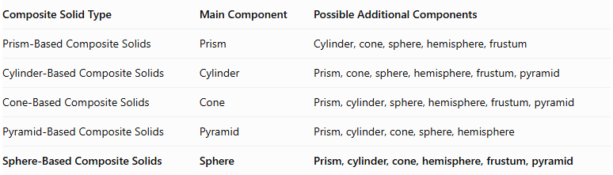
Composite Solid Type | Main Component | Possible Additional Components
Prism-Based Composite Solids | Prism | Cylinder, cone, sphere, hemisphere, frustum
Cylinder-Based Composite Solids | Cylinder | Prism, cone, sphere, hemisphere, frustum, pyramid
Cone-Based Composite Solids | Cone | Prism, cylinder, sphere, hemisphere, frustum, pyramid
Pyramid-Based Composite Solids | Pyramid | Prism, cylinder, cone, sphere, hemisphere
Sphere-Based Composite Solids | Sphere | Prism, cylinder, cone, hemisphere, frustum, pyramid

Applications
# Source: AI Source: Provided by: [Data Path: Persons Table -> ID Column: 1, Name_En Column: Motasem Essam] -> From: [ChatGPT] on [7/25/2026]
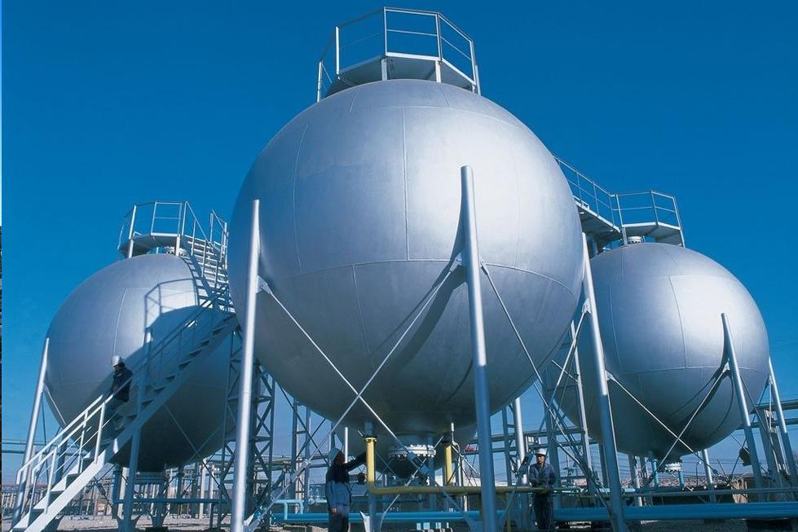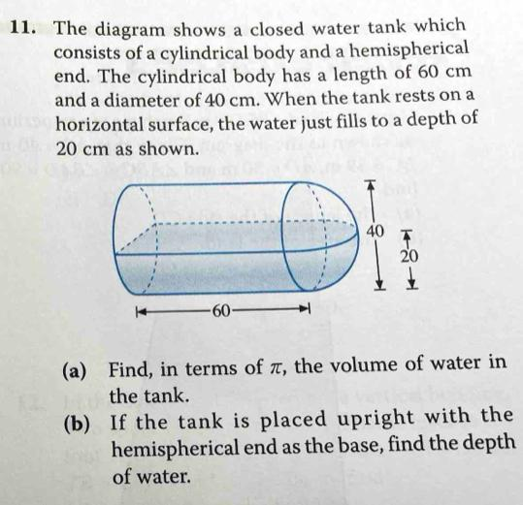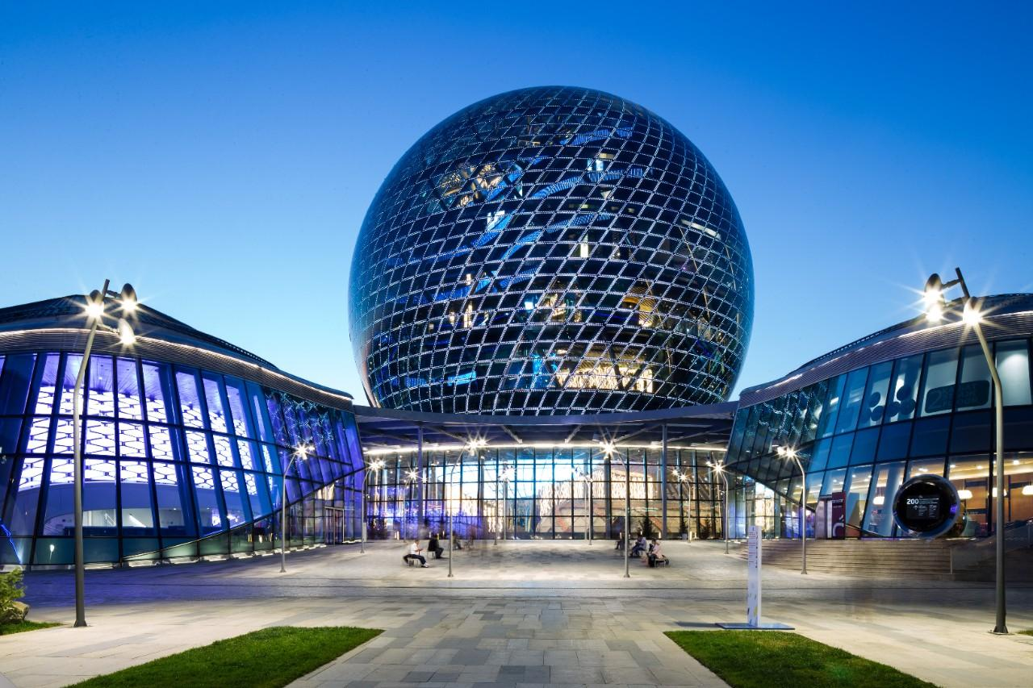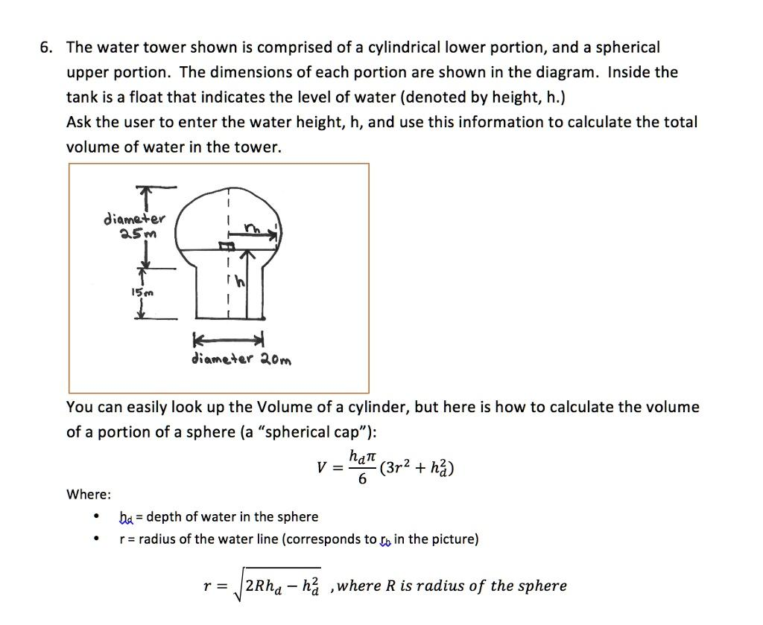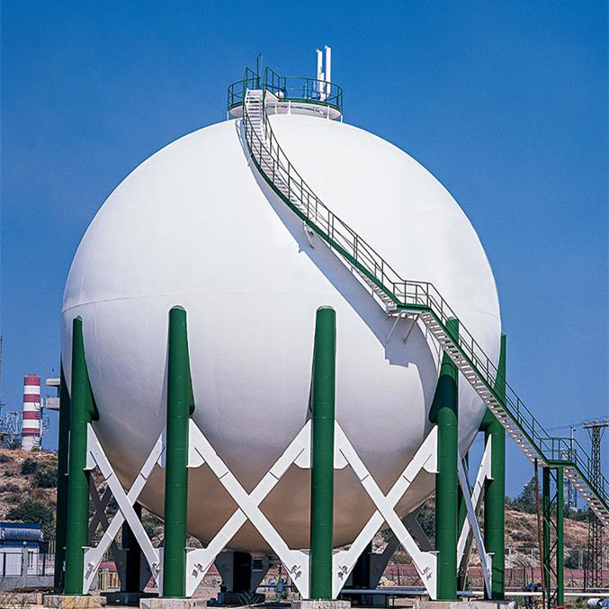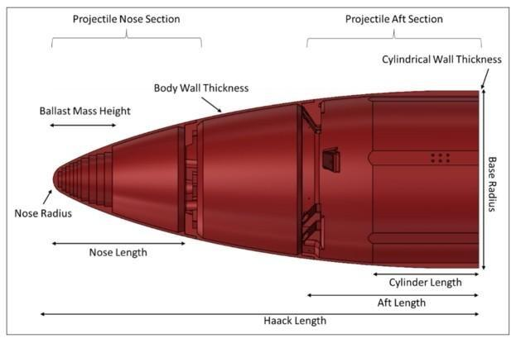
Sphere-based composite solids are commonly found in:
- Architecture: Domes, spherical structures, decorative elements, and building components.
- Mechanical Engineering: Spherical joints, bearings, pressure vessels, and mechanical assemblies.
- Manufacturing: Spherical containers, tanks, molds, and specialized equipment.
- Aerospace Engineering: Spherical fuel tanks, spacecraft components, and aerodynamic structures.
- Automotive Engineering: Ball joints, spherical bearings, and mechanical components.
- Construction: Spherical tanks, domes, and specialized structural elements.
- Product Design: Globes, lamps, toys, decorative objects, and household products.
- Industrial Design: Storage vessels, spherical containers, and equipment housings.
- Computer-Aided Design (CAD): Modeling complex three-dimensional objects using spherical and other geometric components.

Key Points
# Source: AI Source: Provided by: [Data Path: Persons Table -> ID Column: 1, Name_En Column: Motasem Essam] -> From: [ChatGPT] on [7/25/2026]
- Sphere-based composite solids contain at least one spherical component.
- They can combine spheres with prisms, cylinders, cones, hemispheres, frustums, and pyramids.
- Their external surfaces may include flat and curved regions.
- A complete sphere has no flat faces.
- A sphere can be cut or truncated to create a flat circular joining face.
- Their volume is calculated by combining component volumes while accounting for overlaps.
- Their external surface area includes only exposed surfaces.
- Joining surfaces that become internal must not be counted.
- Their arrangements can include coaxial, radial, side-attached, symmetrical, and multiple-component configurations.

Conclusion
# Source: AI Source: Provided by: [Data Path: Persons Table -> ID Column: 1, Name_En Column: Motasem Essam] -> From: [ChatGPT] on [7/25/2026]
Sphere-Based Composite Solids are an important category of composite geometric solids formed by combining spheres or sphere-derived components with other flat-faced or curved-surface solids.
They can produce a wide variety of three-dimensional structures with different arrangements, dimensions, and surface combinations.
Understanding their components, classifications, volume formulas, and external surface-area calculations provides a foundation for studying complex geometric objects and their applications in engineering, architecture, manufacturing, and design.

